A Holistic view on Data Governance, Centralized Data Management Model, Distributed Management Model. Overall industry preference of data governance and data management.
Sayed Nayab Haider

An Industry overview of Data Management and Data Governance including cloud computing infrastructure and impact on data-reliant industries.

Abstract
In this review paper we wish to understand some important aspects of data management & governance in a centralized/distributed data management model, its advantages and disadvantages to data sensitive industries. Few important questions to be answered on our quest would include:
What is Data Mgmt. & Governance, Influences and impact on industries using data as primary asset. Data Management and storage on Cloud infrastructure.
Centralized data management Model and Distributed data management Model, its Advantages and disadvantages to the industry.
What is industries consideration of valued data assets on data governance, risk and compliance and its impact on the overall performance of sensitive sectors like Government, Finance, Healthcare and engineering & production.

This paper is based on my 18+ years of work experience in the field of data and a structured literature review including 100+ research papers and practitioner publications published during 2001-2021.The paper encourage academia and industry professionals to support future research on ideal data management & governance framework keeping future technologies in mind.

15-20 min read

Introductions
The term ‘Governance’ in general refers to the act or process of governing or overseeing the control and direction of something (such as a country or an organization). Here we are interested in the ways an organization goes about ensuring that strategies are set, monitored, and achieved [1]. As IT has become the back-bone of every organization, by definition IT governance becomes an integral part of
any business strategy and falls under the corporate governance.

Data governance (DG) is the practice of organizing and implementing policies, procedures, and standards for the efficient use of an organization's structured/unstructured information resources [2]. Data governance is a set of practices and processes that help ensure that data assets are formally managed in an organization. It establishes the processes and responsibilities that ensure the quality and security of data used in a company or organization.

DG encompasses the people, processes, and information technology needed to ensure that an organization's data is managed consistently and correctly throughout the enterprise. Large organizations typically have a data management team that is responsible for setting goals and priorities, developing a governance model, approving a budget, and selecting the right technologies to use. In an ideal scenario, a data management team would include a manager, a data and decision architect, a data analyst, a data strategist, and a compliance specialist who combine their expertise to make informed decisions and compliance on behalf of their organization.

Organizations try to use technology to solve their financial as well as management problems. While technology solutions such as data lakes and data-governance platforms can help, these should not be considered as the ultimate elixir. Even for highly accomplished data scientists and associates, data processing and cleanup can take up more than half of their productive time. Thereby, limiting scalability and frustrating workers. While many firms struggle to grow data governance successfully, some have done it exceptionally well. Reformulating its management structure necessary for successful data governance. A typical governance structure includes:

- A central data management office (DMO), typically led by a chief data officer (CDO), with a targeted data strategy and governance leaders who set the overall direction and standards.
- Governance roles organized by data domain where the day-to-day work is done.
- A data council that brings domain leaders and the DMO together to connect the data strategy and priorities to the corporate strategy, approve funding, and address issues. [3]

Generally, duty of data stewards will be to set up data quality measurements and monitor trends in data quality KPIs, and perform root cause analysis when thresholds are not met. Data stewards are subject matter experts who understand and communicate the meaning and use of information, and work with other data stewards in the organization as the governing body to make most data decisions. Data owners are typically members of the data council, although they may not be the ultimate decision makers. This group forming a sort of data governance team in an organization.

When done right, a data governance framework allows organizations to make implementing a data governance plan a seamless process that doesn't necessarily require a complete overhaul of existing data governance systems. Here, data governance is a capacity-related data governance concept that enables an organization to ensure high data quality throughout the data lifecycle and implement data governance tools to support business goals. It provides all data management practices with the foundation, strategy and structure needed to ensure that data is managed as an asset and transformed into meaningful information. Data governance helps link information across systems to define meaningful relationships to get the most out of an organization's data and helps ensure that important data is not left behind.

A data governance framework helps organizations shape and categorize existing data assets and establish processes to ensure new data is organized and stored in accordance with data governance best practices. Data governance is a system of decision-making rights and obligations regarding information-related processes, enforced according to agreed models that describe who can do what with which information, when, under what circumstances, and by what method. A good data governance structure also improves horizontal communication between the organization and various departments and disciplines such as development, compliance, governance, quality and IT. While IT and data management teams are often delegated to achieve certain outcomes, it is the responsibility of data stakeholders to ensure that data is used in accordance with best practices and agreed data management processes.

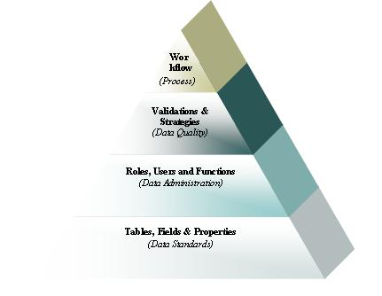

Data Governance can be categorized into four major building blocks:
- Data Standards
- Data Administration
- Data Quality
- Process & Policies. [4]

Best Practices for managing Data Governance Initiatives extends to data security and can impose restrictions on how data is managed and used. Effective data management is also a particularly important component of digital transformation initiatives and can help other business processes such as risk management, business process management, and mergers and acquisitions.

In the simplest terms, data governance establishes policies and procedures around data, while data management enacts those policies and procedures to compile and use that data for decision-making. [5] Data management is the process of taking care of data by identifying the needs, making provisions for its safeguarding, and ensuring its availability. It is important to have a data management strategy in place in order to make data retrieval, analysis, and storage easy and efficient.

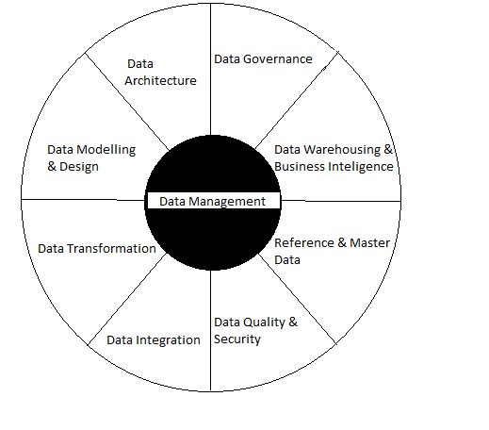
We’ll quickly review the other common elements of data management before focusing on how data governance and data management work together. [5]
- Data Transformation is the process of cleaning and transforming raw data to allow for accurate analysis. This critical first step sometimes gets missed in the rush for reporting and analysis, and organizations find themselves making bad decisions with bad data.
- Data Integration are pipelines used to feed or transfer data from one system to another.
- Data security & Quality consists of the processes put in place to protect your data from unauthorized access or corruption
- Reference Data and Master Data is used to extract, transform, load (ETL) means transforming data to load in an organization’s data warehouse.
- Data warehouses& BI provide a clear route to data analysis by consolidating all data sources.
- Data governance helps define policies and procedures for maintaining data security and compliance.
- Data architecture will be the formal structure for managing data flow.
- Data Models& Design help understand the process of creating a complete picture of the software system and data elements it represents.

Data management also ensures that information is reliable, well-documented, and easy to find and access within the organization, as well as secure, compliant, and confidential. Implementing a data management system allows your organization to be 100% compliant with the latest laws, including the EU General Data Protection Regulation (GDPR), Portability and Accountability, US Health Insurance (HIPAA), Payment Card Industry Data Security Standard (PCI-DSS) and much more, depending on the region one is located.

In the realm of data management systems, organizations mostly group all business data into a cloud data warehouse or data lake—a central data repository to optimized efficient data analytics. Data access control from a centralized platform eliminates permissions, metadata or security policy conflicts that can lead to non-compliance. To manage these complex needs, organizations can use cloud-based data management and attribute-based access control to create location-based policies that control access based on the user's location and data type. Organizations adopting a centralized cloud-based data management platform can save time and effort by implementing a global strategy for managing the availability and use of data on the network, not just within a single database or application. For a multicloud scenario, this means that data and data processing will be distributed across multiple computer systems, servers, and data stores, possibly around the world. Since master data is stored in one system and not in multiple locations and systems, you need to manage security in one place. You can restrict physical access to systems and eliminate the inherent risk of data stored on laptops or PCs, where the risk of theft, loss, or other damage could put your data at risk. You can evaluate, centralized and distributed databases and may chose the management system that works best for your organization. Data from disparate sources will be homogenized and combined, and access can be easily granted to individuals or groups to balance business needs with privacy and security.

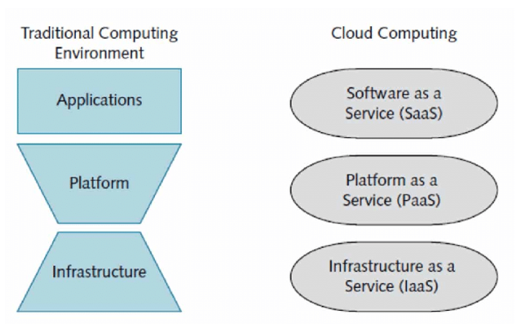

Representation of Traditional Computing Environment and Cloud Computing Environment. [6]

If a single computer is trying to complete a complex task, it might take a very long time to complete the task. However, if multiple computers work together to complete the same task, the task can be completed much faster. This is an example of distributed computing. Distributed computing is when multiple computers work together to solve a common problem.

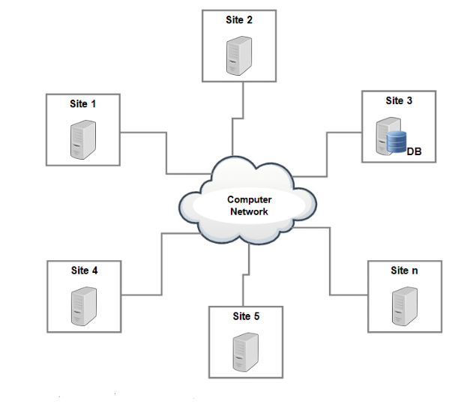
Thus, we have come to our last question of an ideal data management and governance model. Industry preference and future of data management and governance.

The centralized data governance model is a popular solution for organizations seeking to leverage the benefits of the cloud, such as elasticity and scalability, without sacrificing on data quality or security. However, the centralized data governance model has not been adopted across the data management platform space. This is primarily due to the lack of standardized best practices and industry standards for data management in the cloud, which has hindered the adoption of a centralized data governance model. This has left organizations to develop their own data governance processes and standards, which has resulted in uncoordinated data quality and security efforts.

The centralized model has been particularly challenging to adopt in large organizations, which have a large data footprint and require the ability to scale their data management processes across the organization. This has been especially challenging in the context of the Big Data space, where organizations are collecting and storing an ever-increasing amount of data. The centralized data governance framework for Big Data has therefore been hindered by a lack of standardized best practices and industry standards for data management in the Big Data space.

Vis a Vis In the past, businesses used monolithic solutions for their customer relationship management (CRM) and customer data management. However, this approach is no longer adequate to meet the needs of modern businesses. Today's businesses require high levels of flexibility, interoperability, speed, and customization. They also want an easy way to secure their data.

There are advantages and disadvantages to both types. Centralized operating models are simpler and easier to maintain, but they can make some teams feel restricted by the central data governance authority. Federated operating models allow different teams to adopt data governance at different pace, but sometimes it may become more complex or difficult to maintain. As a result, organizations often adopt a hybrid or distributed data management model customized to its needs which balances the advantages of centralization and federation. [8]

A Distributed data management model is simply a collection of multiple, and interrelated databases that are distributed over a computer network. It is a relational schema that facilitates database decentralization for the management and manipulation of data in a database with the aid of same or common language (Abbas et al 2016). Today, data reliant industries know the importance of data is next to nothing. With distributed data management we have the ease of scalability and risk and compliance management.
To effectively manage data governance, risk, and compliance in sensitive sectors like Government, Finance, Healthcare, and Engineering & Production, it is crucial to properly consider the value of data assets in these industries. This involves identifying the sources and types of data that are most valuable, implementing secure storage and access protocols, and developing comprehensive risk management strategies. It is important to involve key stakeholders from each sector in the process to ensure that all considerations are considered. When implemented effectively, this approach can have a significant positive impact on the overall performance and success of the sectors.
Centralized data management models and distributed management models have distinct impacts on industries. With a centralized data management model, data is stored and managed in one central location, while distributed data management models distribute data across multiple locations. The impact of these models on industry ultimately depends on the specific needs and goals of the organization. However, some potential advantages of centralized data management models include greater control and standardization of data, easier maintenance and backup, and improved data security. On the other hand, distributed data management models can offer benefits such as increased flexibility and scalability, better disaster recovery capabilities, and improved network performance. When deciding which model to use, it is important to carefully consider the requirements and infrastructure of the organization, as well as any regulatory or compliance issues.
As far as the industry impact goes, I would conclude that each industry has their own specific requirements and if Health care industry value privacy of the customer, a social messaging website would be considered a grade less on the same since the information on social messaging site is bound to be shared. However, some guideline should be common for the entire industry (e.g.; GDPR).
We need to develop a system where data governance should be region acclimatized, industry specific as well as customer centric.

Annotation:

Cloud computing. A subscription-based delivery model, cloud computing provides the scalability, fast delivery and IT efficiencies required for effective big data analytics. Because it removes many physical and financial barriers to aligning IT needs with evolving business goals, it is appealing to organizations of all sizes.
Data management. Data needs to be high quality and well-governed before it can be reliably analyzed. With data constantly flowing in and out of an organization, it's important to establish repeatable processes to build and maintain standards for data quality. Once data is reliable, organizations should establish a master data management program that gets the entire enterprise on the same page.
Data mining. Data mining technology helps you examine large amounts of data to discover patterns in the data – and this information can be used for further analysis to help answer complex business questions. With data mining software, you can sift through all the chaotic and repetitive noise in data, pinpoint what's relevant, use that information to assess likely outcomes, and then accelerate the pace of making informed decisions.
Data storage, including the data lake and data warehouse. It's vital to be able to store vast amounts of structured and unstructured data – so business users and data scientists can access and use the data as needed. A data lake rapidly ingests large amounts of raw data in its native format. It’s ideal for storing unstructured big data like social media content, images, voice and streaming data. A data warehouse stores large amounts of structured data in a central database. The two storage methods are complementary; many organizations use both. [9]

Sources:

[1] K. Weber, B. Otto, and H. Osterle, “One Size Does Not Fit All — A Contingency Approach to Data Governance,” ACM J. Data Inf. Qual., vol. 1, no. 1, p. 4:1-4:27, 2009.

[2] Data Governance Maturity – An Overview by Anne Marie Smith, Ph.D.

[3] www.mckinsey.com/business-functions/mckinsey-digital/our-insights/designing-data-governance-that-delivers-value.

[4] SAP MDM & Data Governance | SAP Blogs

[5] www.tableau.com/learn/articles/data-management-vs-data-governance.

[6] Cloud computing layers | Download Scientific Diagram (researchgate.net)

[7] Architecture of Centralized Database System. | Download Scientific Diagram (researchgate.net)

[8] www.collibra.com/us/en/blog/the-benefits-of-a-flexible-operating-model-in-data-governance

[9] https://www.sas.com/en_us/insights/analytics/data-mining.html

